### Use Case Name:

Blocked Order Release Recommendation

### Use Case (internal) Alias:

BORR

### Consumer Product:

AI Credit Cloud & Autonomous Credit

### Business Context:

Roughly >80% of the blocked orders are eventually released by the sellers. The decision is usually made on “When” to release. Typical attributes of consideration by the Credit teams involve Risk Profile of the customer, Past Payment Behaviour, Credit Limit Overshoot etc. The analyst decisions are dictated by global credit policies and reflected in the data.

The same data can be used to train AI models to mimic the Analyst decision making and provided as recommendations both w.r.t. immediate action on the order e.g. Release or not as well as strategic change on the customer e.g. Temporarily/Permanently increase Credit Limit. The recommendations can also be used to automatically release Blocked Orders.

### What the AI Model Does

It recommends whether to unblock a blocked order or not and accompanying action like taking collateral/increasing credit limit etc) and a reason for that recommendation.

### Business Benefits

* Increase analyst productivity by accelerating the Blocked Order decision making which leads to Sales Acceleration and faster revenue realization & Minimized impact on the business operations of the buyers

### Usual Execution Frequency:

(Once a day/week/month/hour/whenever the user opens that screen ……)

Real time whenever an order is blocked (done by an background Agent job OR by user from UI)

### Impacted Business Metrics:

* Average time taken to release a Blocked Order

### Input to the AI Model:

1. AR data:
   1. Invoice Number (int)
   2. Document Number (int)
   3. Customer Number (int)
   4. Company code
   5. Due Date (date)
   6. Clearing Date (date)
   7. Invoice Date (date)
   8. Invoice amount (date)
   9. Payment terms (int)
   10. Order id (int)
   11. Disputed Amount (int)
2. Order Data:
   1. Customer Number
   2. Order amount
   3. Order date
   4. Order create date
   5. Order Release date
   6. Order initial status
   7. Order current status
   8. Exposure when order is received (decimal)
   9. Credit limit when order is received (decimal)
3. Customer Data
   1. Credit limit (global currency)
   2. Risk class
   3. Credit Exposure (Global currency)
   4. Past due (global currency)
4. Promise to Pay (P2P) data
   1. Committed on (date)
   2. Committed for (date)
   3. Committed Amount (Global Currency) - total amount committed by the customer for the next 30 days after release date
   4. No.of commitments - No.of commitments made by the customer for the next 30 days after release date
5. Credit limit history
   1. Previous credit limit (global Currency)
   2. Update credit limit (global currency)
   3. Reason
   4. Changed Date (date)

(at training time + execution time)

At training time: Historical Payment Commitments, Closed Invoices data

At execution time: Blocked Order, Credit data

### Screenshot:

(where the AI model prediction based info is shown to customer)

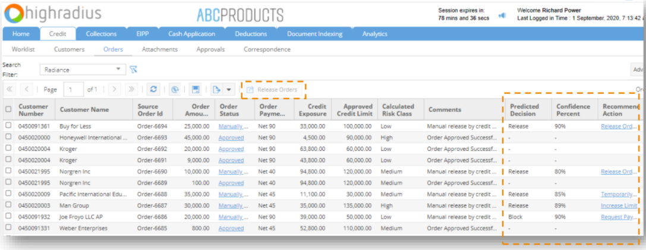

### IP/Special Value brought in by HighRadius here:

(why can’t customer IT team do it themselves taking raw data they entered into Collections etc)

Eg of derived features:

* overshoot on credit limit
* Past due amount

### Patent:

No